Team Organization
Meetings
Our group meetings are an hour long each at the computer science lab, being held on Mondays from 8:30 am to 9:30 am and an optional meeting from 2:30pm to 3:30pm and Thursdays from 10:00 am to 11:00 am. The optional meetings are considered optional as they allow our team to get together to work on tasks which require collaboration, but we may not all have to be there for certain tasks. As for our client meetings, it is being held at his office and we will be meeting with our client once every two weeks which will replace our optional meeting on Mondays from 2:30pm to 3:30pm to discuss and ask questions about our project.
Sample Agenda
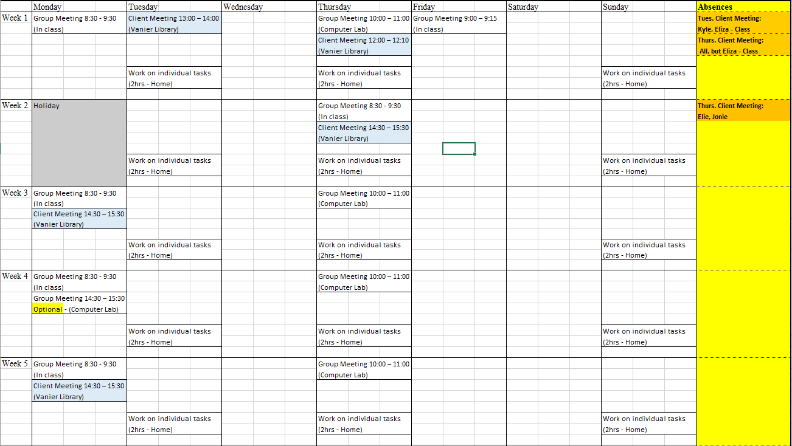

Online Repositories
Currently the Online repository that we are using is GitHub to store and share all files between all team members.
Communications
Regarding communication, our team is communicating through an application called discord for little discussions and questions that can be answered quickly, but when we need to discuss of something major, it is to be done in person with all team members present. We also use discord to remind members about certain deadlines and important dates. Finally, we have a bot within the server which is linked to our GitHub repository and notifies members whenever there is a change to the repository.
Work
Work that is to be done for all team members can be done at home or the lab, but team members are to fulfill 4-6 hours a week, on average, depending on if we are ahead of schedule or behind. If there is work that is needed for all team members to be present, then the work will be done in the lab.
Areas of Responsibility
We have decided to have the team leader of each deliverable be the one responsible for communicating with the client and making sure the reports are formatted and delivered on time. This makes it less confusing for the members overall.
Primary Client Contact
Deliverable 2 ----------------- Jonnie Klein Quezada
Deliverable 3 ----------------- Eliza Gaudio
Deliverable 4 ----------------- Kyle Nancoo
Deliverable 5 ----------------- Elie Sader
Deliverable 6 ----------------- Kevin Hirsh
Deliverable 7 ----------------- Jonnie Klein Quezada
Reports
Deliverable 1 ----------------- Kevin Hirsh
Deliverable 2 ----------------- Jonnie Klein Quezada
Deliverable 3 ----------------- Eliza Gaudio
Deliverable 4 ----------------- Kyle Nancoo
Deliverable 5 ----------------- Elie Sader
Deliverable 6 ----------------- Kevin Hirsh
Deliverable 7 ----------------- Jonnie Klein Quezada
Contact Information
Kyle Nancoo Email: kylenancoo3@gmail.com Tel.: (514) 661-2820
Eliza Gaudio Email: eliza_gaudio@hotmail.com Tel.: (514) 557-2828
Elie Sader Email: sader_elite@hotmail.com Tel.:(514) 585-6215
Jonnie Klein Quezada Email: jonniequezada@gmail.com Tel.: (514) 946-9008
Kevin Hirsh Email: khirsh98@gmail.com Tel.: (514) 836-5525

